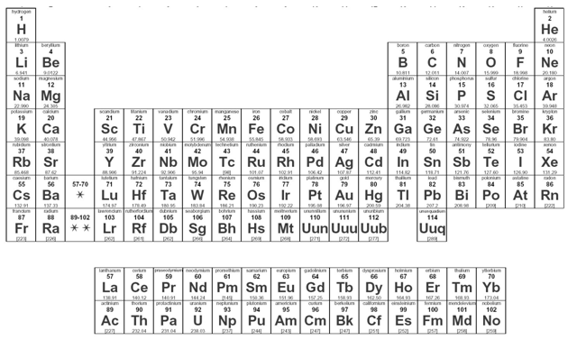

Key Vocabulary:

Group:

Period:

Representative element:

Transition element:

Metal:

Alkali metal:

Alkaline earth metal:

Transition metal:

Inner transition metal:

Nonmetal:

Halogen:

Noble gas:

Metalloid:

