Day 1 Materials:

Entrance Slip
For each of the following, decide if the relationship between the organisms is (+,+) both benefit, (+,0) one is benefited and on is not affected, (+,-) one is benefited and one is harmed, or (-,-) both are harmed. On the lines provided, describe in 1-2 sentences why you came to that conclusion.

- Ostriches and gazelles feed next to each other. They both watch for predators and alert each other to danger. Because the visual abilities of the two species are different, they can identify threats that the other animal would not see as readily.

Relationship: _____________________________________________
Reasoning:_______________________________________________________________________________________________________________________________________________________________________________________________________________________________________________________________________________________

- Ticks will feed on a deer’s blood and the deer loses blood.

Relationship: _____________________________________________
Reasoning:_______________________________________________________________________________________________________________________________________________________________________________________________________________________________________________________________________________________
- In Africa, zebras gather by the limited ponds during the dry season for water. Crocodiles wait in the water for a zebra to come close. They then snatch the zebra in their mouth and drag it under the water.

Relationship: _____________________________________________
Reasoning:_______________________________________________________________________________________________________________________________________________________________________________________________________________________________________________________________________________________

Exit Slip
For each of the following, decide which of the 5 kinds of organism interactions these are examples of (mutualism, commensalism, predation, parasitism, competition). On the lines provided, describe in 1-2 sentences why you came to that conclusion. State if the organisms are being benefitted, harmed, or not affected.

1) Male lions fight each other for control of a pride of female lions. One of the lions will win the fight and either gain or keep control of the pride, while the other lion loses, and is often harmed.

Relationship: _____________________________________________
Reasoning:_______________________________________________________________________________________________________________________________________________________________________________________________________________________________________________________________________________________

2) Some species of rhinoceros eat a fruit commonly called a “Rhino Apple.” By the time the fruit is digested, the rhino is far away from where it originally ate the fruit, and expels the seed.

Relationship: _____________________________________________
Reasoning:_______________________________________________________________________________________________________________________________________________________________________________________________________________________________________________________________________________________
3) A sparrow will build its nest under the nest of an osprey. The smaller birds get protection because other predators will not mess with the osprey. The ospreys ignore the presences of the sparrows.

Relationship: _____________________________________________
Reasoning:_______________________________________________________________________________________________________________________________________________________________________________________________________________________________________________________________________________________

Day 2 Materials:

Entrance Slip

On your own, state what kind of relationship is being described. Then write 1-2 sentences explaining why you think that.

1) A whale is unaffected by the attached remora fish feeding on the whale’s leftover food.

Relationship: _____________________________________________
Reasoning:_______________________________________________________________________________________________________________________________________________________________________________________________________________________________________________________________________________________

2) Spider crabs are camouflaged by the green-brown algae growing on their shells.

Relationship: _____________________________________________
Reasoning:_______________________________________________________________________________________________________________________________________________________________________________________________________________________________________________________________________________________

Exit Slip
1) African ants living in acacia trees feed on leaf-eating insects found on the tree.
Relationship: _____________________________________________
Reasoning:_______________________________________________________________________________________________________________________________________________________________________________________________________________________________________________________________________________________

2) Question: Mangrove trees are common to the Florida Everglades. The tree roots serve as a place for freshwater oysters to attach when the tide is high, as shown in the picture below. The oysters are protected from predators when attached to the roots underwater.
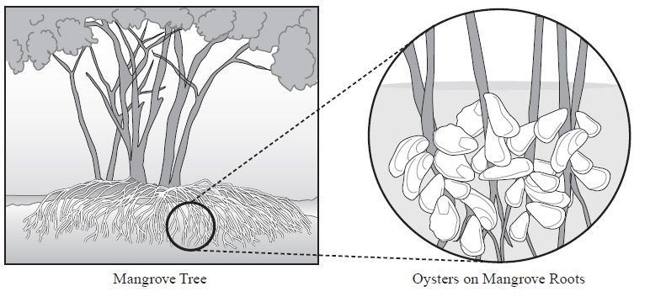
The oysters do not harm the trees nor do they provide any benefit to the trees. Which of the following relationships is most similar to the relationship between the mangrove trees and the oysters? Answer Options: A. African ants living in acacia trees feed on leaf-eating insects found on the tree.
B. Spider crabs are camouflaged by the green-brown algae growing on their shells.
C. A whale is unaffected by the attached remora fish feeding on the whale’s leftover food.
D. Bees fly from one flowering plant to another gathering nectar and pollinating the flowers.

(Note: Mrs. Hayden, if you cannot see the picture, because word is acting up on my computer, please find it at: http://www.floridastandards.org/Standards/PublicPreviewSampleTestItem401.asp

What do I do?

- You will be creating a song or a poem.
- In the song or poem you must include ONE example of each kind of relationship.
- For each relationship, you need to tell what organisms are involved and how they are being affected by the relationship (benefiting, harmed, no effect).
- You will present this song or poem at the end of class.
  - You will only have 20 minutes to complete this in class. Watch the timer and use your time wisely.
- Each person in your group MUST say at least one sentence in the song or poem.

You will receive ONE point for listing examples of each of the following types of interactions. You only need to mention the relationship ONCE to receive credit for that category:
- Mutualism.
- Predation.
- Commensalism.
- Parasitism.
- Competition.

You will receive ONE point for describing which organism benefits, is harmed, or is not affected for each type of interaction:
- Mutualism
- Organism 1
- Effect on organism 1
(benefited, harmed, not affected)
- Organism 2
- Effect on organism 2
(benefited, harmed, not affected)
- Predation
- Organism 1
- Effect on organism 1
(benefited, harmed, not affected)
- Organism 2
- Effect on organism 2
(benefited, harmed, not affected)
- Commensalism
- Organism 1
- Effect on organism 1
(benefited, harmed, not affected)
- Organism 2
- Effect on organism 2
(benefited, harmed, not affected)
- Parasitism
- Organism 1
- Effect on organism 1
(benefited, harmed, not affected)
- Organism 2
- Effect on organism 2
(benefited, harmed, not affected)
- Competition
- Organism 1
- Effect on organism 1
(benefited, harmed, not affected)
- Organism 2
- Effect on organism 2
(benefited, harmed, not affected)

Participation from each group member is worth 5 points total. You will have a point deducted for each group member who does not participate, so please make sure that each person says at least one sentence in the song or poem.
- Group Participation

The whole assignment is worth 30 points total.
Checking off a box gives you 1 point.
Total group participation gets you 5 points.
Points will be deducted for each group member who does not participate.

